

Visiting the dentist

Social story

Today I am going to the dentist at Children’s Village. The dentist helps keep my teeth clean and healthy.

I will check in at the front desk.

I will wait my turn in the waiting room with my family.

When my name is called, I will go to see the dentist.

The dentist and assistant will say hi to me and take care of my teeth.

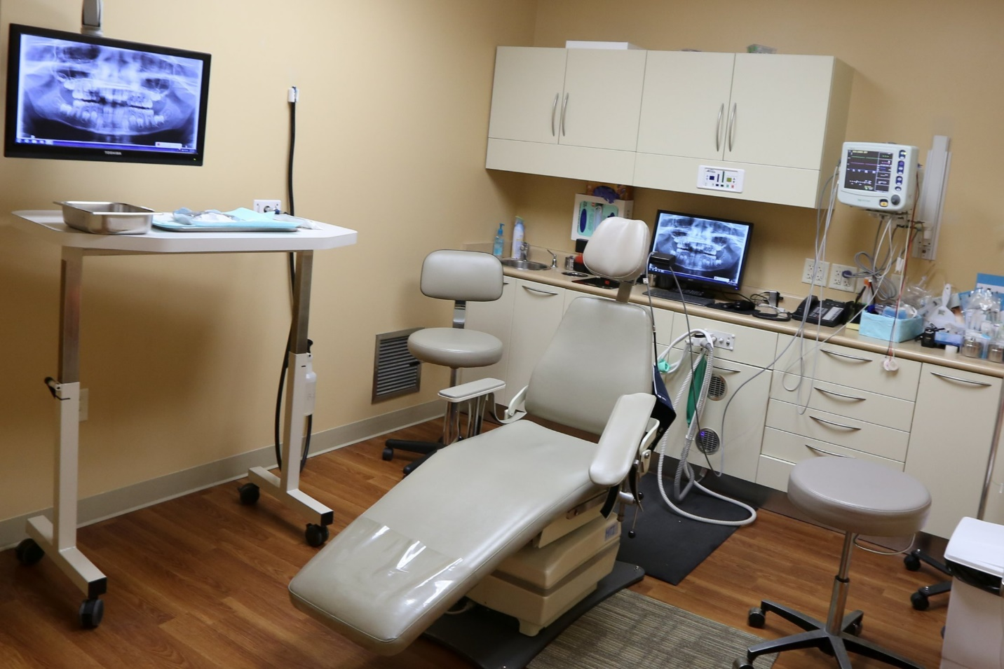

I will sit in a big chair. The chair will move and lay back. I have to sit still in the chair.

When my teeth are checked the dentist will wear a mask, a coat, and gloves.

Then dentist and assistant will use special instruments to clean and check my teeth.



I will help by opening my mouth wide so the dentist can see my teeth.

When I am all done, I will get to pick a prize.